

2022 iGEM InterLab study

# Experiment 2 - Using the three color calibration protocol: Does the order of transcriptional units influence their expression strength?

In this experiment, your team will measure the fluorescence of six devices that encode two fluorescence proteins in two transcriptional units. The devices differ in the order of the transcriptional units. You will calibrate the fluorescence of these devices to the calibrant dyes and the optical density of the culture to the cell density calibrant.

This experiment aims to assess the lab-to-lab reproducibility of the three color calibration protocol when two fluorescent proteins are expressed in the same cell. Besides this technical question, it also addresses a fundamental synthetic biology question: does the order of the transcriptional units (that encode for the two different fluorescent proteins) on the devices influence their expression levels?

Before performing the cell measurements, you need to perform all the calibration measurements. Please do not proceed unless you have completed the calibration protocol. Completion of the calibrations will ensure that you understand the measurement process and that you can take the cell measurements under the same conditions. For consistency and reproducibility, we are requiring all teams to use E. coli K-12 DH5-alpha. If you do not have access to this strain, you can request streaks of the transformed devices from another team near you. If you are absolutely unable to obtain the DH5-alpha strain, you may still participate in the InterLab study by contacting the Engineering Committee (interlab [at] igem [dot] org) to discuss your situation.

For all below indicated cell measurements, you must use the same type of plates and the same volumes that you used in your calibration protocol. You must also use the same settings (e.g., filters or excitation and emission wavelengths) that you used in your calibration measurements. If you do not use the same type of plates, volumes, and settings, the measurements will not be valid.

Protocol summary: You will transform the eight devices listed in Table 1 into E. coli K-12 DH5-alpha cells. The next day you will pick two colonies from each transformation (16 total) and use them to inoculate 12 mL overnight cultures (this step is still in tubes). Each of these 16 overnight cultures will be used to inoculate four wells in a 96-well plate (200uL each, 4 replicates) for measurement and one test tube (12 mL) for growth. You will measure how fluorescence and optical density develops over 6 hours by taking measurements at time point 0 hour and at time point 6 hours. Follow the protocol below and the visual instructions in Figure 1 and Figure 2.

## Protocol Outputs:

* baseline absorbance of culture (day 2) measurements of cultures (0 hr timepoint)
* 0 hr absorbance timepoint measurements of plate 1
* 0 hr green fluorescence timepoint measurements of plate 1
* 0 hr blue fluorescence timepoint measurements of plate 1
* 0 hr red fluorescence timepoint measurements of plate 1
* 6 hr absorbance timepoint measurements of plate 2
* 6 hr green fluorescence timepoint measurements of plate 2
* 6 hr blue fluorescence timepoint measurements of plate 2
* 6 hr red fluorescence timepoint measurements of plate 2

## Protocol Materials:

* [*E. coli* DH5 alpha competent cells](https://identifiers.org/taxonomy:668369)
* [Negative control 2022](http://parts.igem.org/Part:BBa_J428100)
* [Positive control 2022 Green](http://parts.igem.org/Part:BBa_J428112)
* [Positive control red (mCherry) Exp 2](http://parts.igem.org/Part:BBa_J428101)
* [Test Device 1 Exp 2 (Dual construct Green and Blue)](http://parts.igem.org/Part:BBa_J428106)
* [Test Device 2 Exp 2 (Dual construct Green and Red)](http://parts.igem.org/Part:BBa_J428107)
* [Test Device 3 Exp 2 (Dual construct Red and Blue)](http://parts.igem.org/Part:BBa_J428105)
* [Test Device 4 Exp 2 (Dual construct Blue and Red)](http://parts.igem.org/Part:BBa_J428108)
* [Test Device 5 Exp 2 (Dual construct Red and Green)](http://parts.igem.org/Part:BBa_J428104)
* LB Broth + Chloramphenicol (34 ug/mL)
* LB Agar + Chloramphenicol (34 ug/mL)
* [Chloramphenicol stock solution (34 mg/mL)](https://pubchem.ncbi.nlm.nih.gov/compound/5959)
* Ice
* Plate reader
* Shaking incubator
* Petri dish (x 8)
* culture tube (x 32)
* 1.5mL microfuge tube (x 32)
* 50mL conical tube (x 16)
* 96 well microplate (x 2)

#### Table 1: Part Locations in Distribution Kit

|  |  |  |
| --- | --- | --- |
| Device | Part Name | Coordinate |
| Negative Control 2022 | BBa_J428100 | Kit Plate 1 Well 12M |
| Positive Control 2022 Green | BBa_J428112 | Kit Plate 1 Well 14C |
| Positive Control red (mCherry) Exp 2 | BBa_J428101 | Kit Plate 1 Well 12I |
| Test Device 1 Exp 2 (Dual constr. Green and Blue) | BBa_J428106 | Kit Plate 1 Well 12G |
| Test Device 2 Exp 2 (Dual constr. Green and Red) | BBa_J428107 | Kit Plate 1 Well 3L |
| Test Device 3 Exp 2 (Dual constr. Red and Blue) | BBa_J428105 | Kit Plate 1 Well 5J |
| Test Device 4 Exp 2 (Dual constr. Blue and Red) | BBa_J428108 | Kit Plate 1 Well 14E |
| Test Device 5 Exp 2 (Dual constr. Red and Green) | BBa_J428104 | Kit Plate 1 Well 5L |

## Protocol Steps:

**Day 1**

1. Obtain 8 x Petri dish containing LB Agar + Chloramphenicol (34 ug/mL) growth medium for culturing transformant strains
2. Transform Negative control 2022 DNA into *E. coli* DH5 alpha competent cells. Repeat for the remaining transformant DNA: Positive control 2022 Green, Positive control red (mCherry) Exp 2, Test Device 1 Exp 2 (Dual construct Green and Blue), Test Device 2 Exp 2 (Dual construct Green and Red), Test Device 3 Exp 2 (Dual construct Red and Blue), Test Device 4 Exp 2 (Dual construct Blue and Red), and Test Device 5 Exp 2 (Dual construct Red and Green). Plate transformants on LB Agar + Chloramphenicol (34 ug/mL) transformant strains plates. Incubate overnight (for 16 hour) at 37.0°C.

**Day 2**

1. Obtain 16 x culture tubes to contain culture (day 1)
2. Pick 2 colonies from each transformant strains plate.
3. Inoculate 2 colonies of each transformant transformant strains, for a total of 16 cultures. Inoculate each into 12.0mL of LB Broth + Chloramphenicol (34 ug/mL) in culture (day 1) and grow overnight (for 16.0 hour) at 37.0°C and 220 rpm.

**Day 3**

1. Obtain 16 x culture tubes to contain culture (day 2)
2. Dilute each of 16 culture (day 1) samples with LB Broth + Chloramphenicol (34 ug/mL) into the culture tube at a 1:10 ratio and final volume of 12.0mL. Maintain at 4.0°C while performing dilutions. (This can be also performed on ice).
3. Obtain 16 x 1.5mL microfuge tubes to contain cultures (0 hr timepoint)
4. Hold cultures (0 hr timepoint) on ice. This will prevent cell growth while transferring samples.
5. Transfer 1.0mL of each of 16 culture (day 2) samples to 1.5mL microfuge tube containers to contain a total of 16 cultures (0 hr timepoint) samples. Maintain at 4.0°C during transfer. (This can be also performed on Ice).
6. Measure baseline absorbance of culture (day 2) of cultures (0 hr timepoint) at 600.0nm.
7. Obtain 16 x 50mL conical tubes to contain back-diluted culture. The conical tube should be opaque, amber-colored, or covered with foil.
8. Back-dilute each of 16 culture (day 2) samples to a target OD of 0.02 using LB Broth + Chloramphenicol (34 ug/mL) as diluent to a final volume of 12.0mL. Maintain at 4.0°C while performing dilutions.

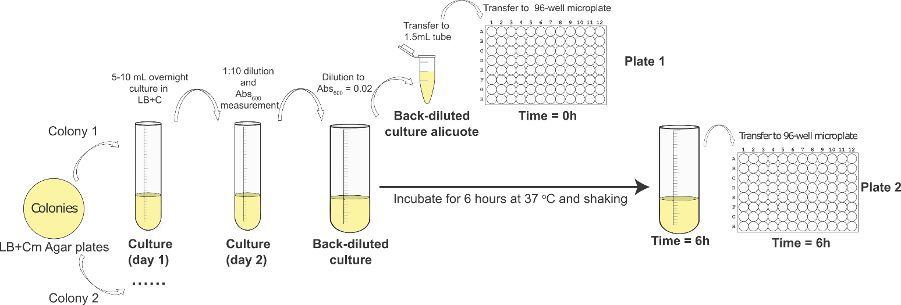

Fig 1: Visual representation of protocol

1. Obtain 16 x 1.5mL microfuge tubes to contain back-diluted culture aliquots
2. Hold back-diluted culture aliquots on ice. This will prevent cell growth while transferring samples.
3. Transfer 1.0mL of each of 16 back-diluted culture samples to 1.5mL microfuge tube containers to contain a total of 16 back-diluted culture aliquots samples. Maintain at 4.0°C during transfer. (This can be also performed on Ice).
4. Obtain a 96 well microplate to contain plate 1
5. Hold plate 1 on ice.
6. Transfer 200.0uL of each back-diluted culture aliquots sample to 96 well microplate plate 1 in the wells indicated in the plate layout. Maintain at 4.0°C during transfer.
7. Transfer 200.0uL of LB Broth + Chloramphenicol (34 ug/mL) sample to wells A1:H1, A10:H10, A12:H12 of 96 well microplate plate 1. Maintain at 4.0°C during transfer. These samples are blanks.

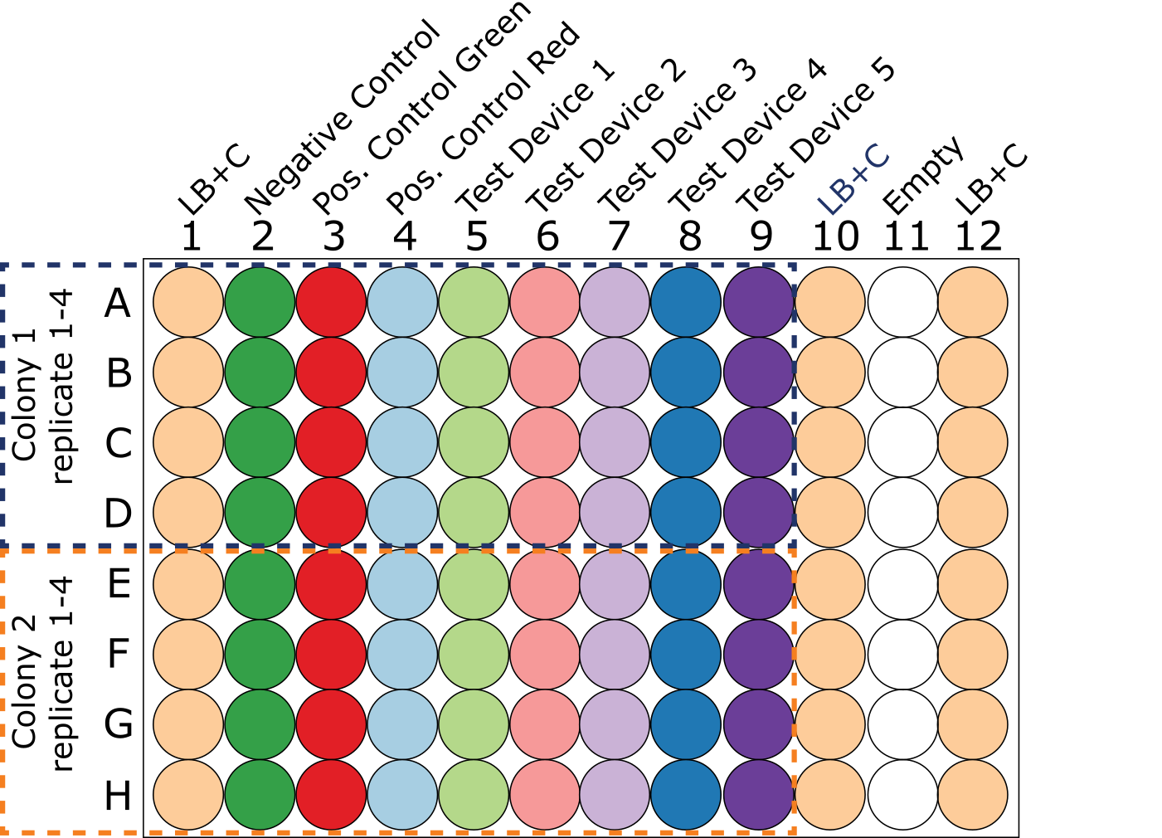

Fig 2: Plate layout

1. Measure 0 hr absorbance timepoint of plate 1 at 600.0nm.
2. Measure 0 hr green fluorescence timepoint of plate 1 with excitation wavelength of 488.0nm and emission filter of 530.0nm and 30.0nm bandpass.
3. Measure 0 hr blue fluorescence timepoint of plate 1 with excitation wavelength of 405.0nm and emission filter of 450.0nm and 50.0nm bandpass.
4. Measure 0 hr red fluorescence timepoint of plate 1 with excitation wavelength of 561.0nm and emission filter of 610.0nm and 20.0nm bandpass.
5. Incubate all back-diluted culture samples for 6.0 hour at 37.0°C at 220 rpm.
6. Hold all back-diluted culture samples on ice. This will inhibit cell growth during the subsequent pipetting steps.
7. Obtain a 96 well microplate to contain plate 2
8. Hold plate 2 on ice.
9. Transfer 200.0uL of each back-diluted culture sample to 96 well microplate plate 2 in the wells indicated in the plate layout. Maintain at 4.0°C during transfer.
10. Transfer 200.0uL of LB Broth + Chloramphenicol (34 ug/mL) sample to wells A1:H1, A10:H10, A12:H12 of 96 well microplate plate 2. Maintain at 4.0°C during transfer. These are the blanks.
11. Measure 6 hr absorbance timepoint of plate 2 at 600.0nm.
12. Measure 6 hr green fluorescence timepoint of plate 2 with excitation wavelength of 485.0nm and emission filter of 530.0nm and 30.0nm bandpass.
13. Measure 6 hr blue fluorescence timepoint of plate 2 with excitation wavelength of 405.0nm and emission filter of 450.0nm and 50.0nm bandpass.
14. Measure 6 hr red fluorescence timepoint of plate 2 with excitation wavelength of 561.0nm and emission filter of 610.0nm and 20.0nm bandpass.
15. Import data for baseline absorbance of culture (day 2) measurements of cultures (0 hr timepoint), 0 hr absorbance timepoint measurements of plate 1, 0 hr green fluorescence timepoint measurements of plate 1, 0 hr blue fluorescence timepoint measurements of plate 1, 0 hr red fluorescence timepoint measurements of plate 1, 6 hr absorbance timepoint measurements of plate 2, 6 hr green fluorescence timepoint measurements of plate 2, 6 hr blue fluorescence timepoint measurements of plate 2, 6 hr red fluorescence timepoint measurements of plate 2 into provided Excel file.

* Protocol version: 1.1b